LEARNING AND CREATING ( REIKI AND THE SENIOR CENTER )

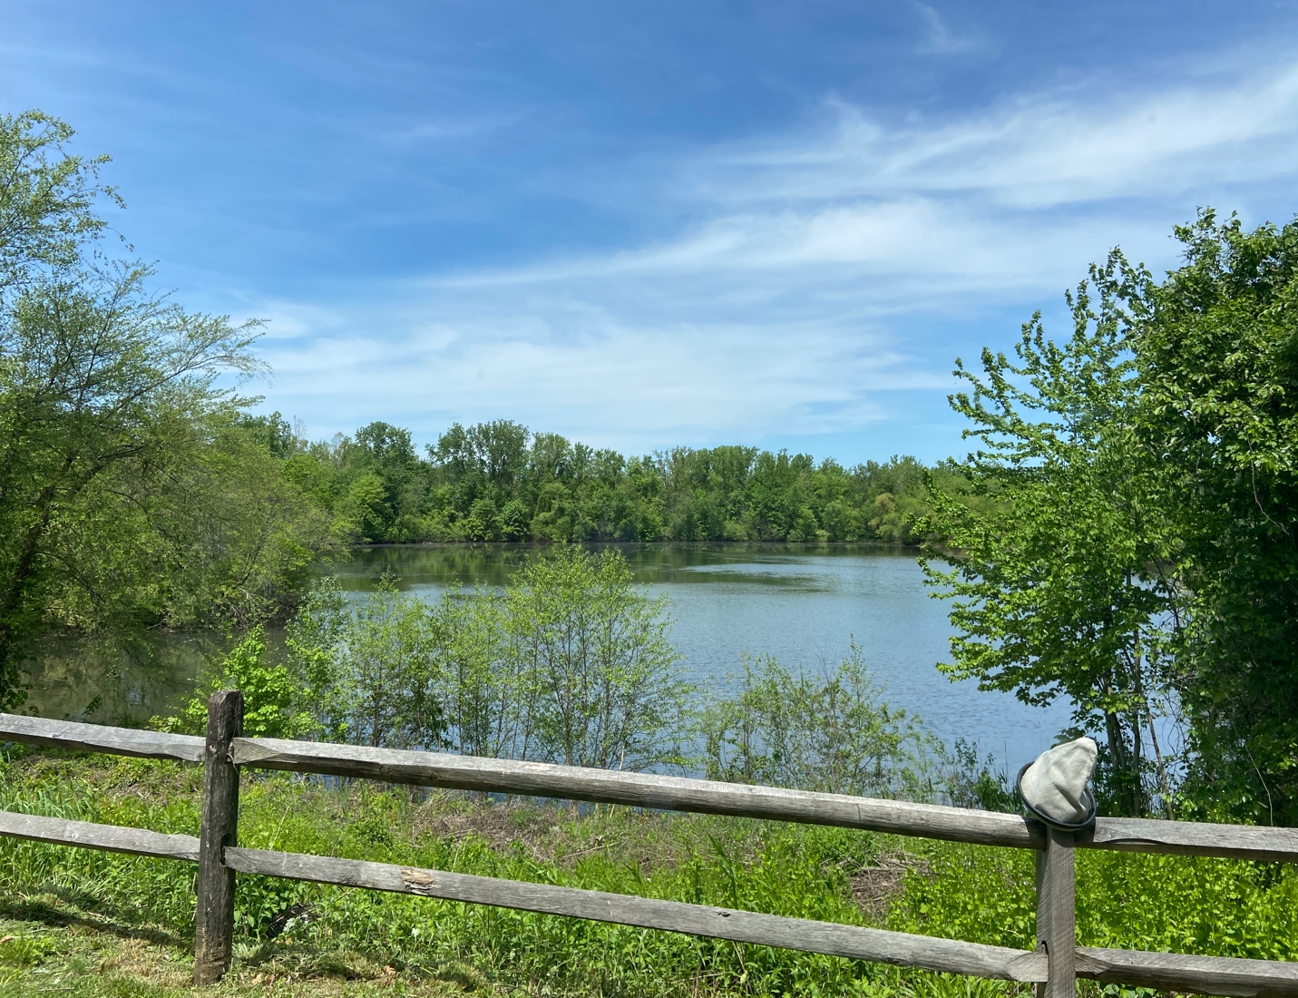

Where am I?

Sitting by the window at the Lakeside Café at the Wallingford Senior Center between giving Reiki sessions and attending classes. I enjoy this lovely view as it changes with the seasons. Whatever season we have, it promotes serenity.

Did I ever expect to be a member and active participant in a senior center? No way! I was never one to play card games, bridge or Mahjong like my mom enjoyed. What brought me here to this beautiful changing view in the picture above, Reiki!!

I attended The Celebration of Reiki conference in the Boston area for the first time in April 2016. There were Practitioners at this conference who were Reiki Practitioners at various senior centers. I was encouraged to contact The Wallingford Senior Center to offer their members Reiki treatments.

I myself was inspired by my clients there. I listened as a client in his early 60’s told me about the hikes that were offered. Hiking is one of my passions. I had another who was involved in Tap dancing. There was another young senior who would bring her mother to the “Memory Lane “program while enjoying the activities in the Center. She explained that the Senior Center was like a free country club.

I decided to become a member. Shortly following becoming a member I became a Reiki Master and began teaching at Adult Education and a performing arts center. I thought, why not teach the members of the Senior Center as well.

The Public Health Nurse at the Wallingford Senior Center became one of my first students as well as a good, supportive friend who has been helpful with my classes. I went to the Program Director with an offer to hold Reiki classes at the Senior Center. It was well received. Four wonderful students signed up for my Reiki 1 class. What a great class we had! There were more classes following this.

One of my Reiki 1 students facilitates a class called A.G.E.
(Aging Gracefully, Essentials) She asked me to collaborate with her regarding this class in leading meditations. I found myself drawn to some of the artist studios and crafter’s corners she facilitates. Again, my creativity evolved. I started attending a class making therapeutic artist boards, which allowed me to combine my passion for sea glass collecting with my scrapbooking. This has given me an opportunity to participate in an art show at the Wallingford Senior Center. I will also be showing my work at The Buttonwood Tree Performing Arts Center, where I hold my Reiki classes. I will be sharing that art Show with my Reiki student and art teacher from the Senior Center.

Guess where I am at the beginning of each month? At the Wallingford Senior center signing up for classes and the monthly hike. I started a conversation with a very nice gentleman who was in line with me. I learned that his daughter and granddaughter have taken my Reiki 1 and 2 classes. He was extremely proud of them.

See all the wonderful things Reiki practice brought me? It was just what I needed, my creative, authentic self. I am so glad Reiki brought me to the senior center.

